Ideation Phase
Brainstorm & Idea Prioritization Template

Date | 09 January 2026
Project Name | Calculating Family Expenses using Service Now

Brainstorm & Idea Prioritization Template:
Brainstorming is a creative process that fosters open collaboration and encourages every team member to share ideas freely without judgment. It focuses on generating a large volume of innovative and out-of-the-box ideas that can later be refined into practical solutions. This approach allows team members to build on each other’s thoughts, promoting collective creativity and problem-solving. In the context of “Calculating Family Expenses using ServiceNow,” brainstorming helps identify diverse ways to automate expense tracking, simplify calculations, and enhance user experience through effective collaboration and imagination.
Reference: https://www.mural.co/templates/brainstorm-and-idea-prioritization
Step-1: Team Gathering, Collaboration and Select the Problem Statement
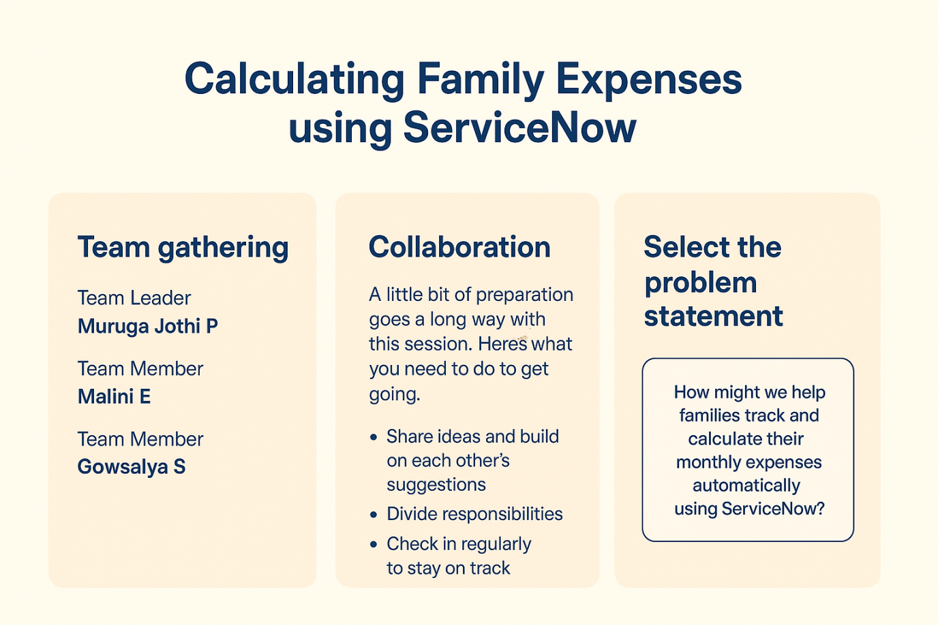

Step-2: Brainstorm, Idea Listing and Grouping
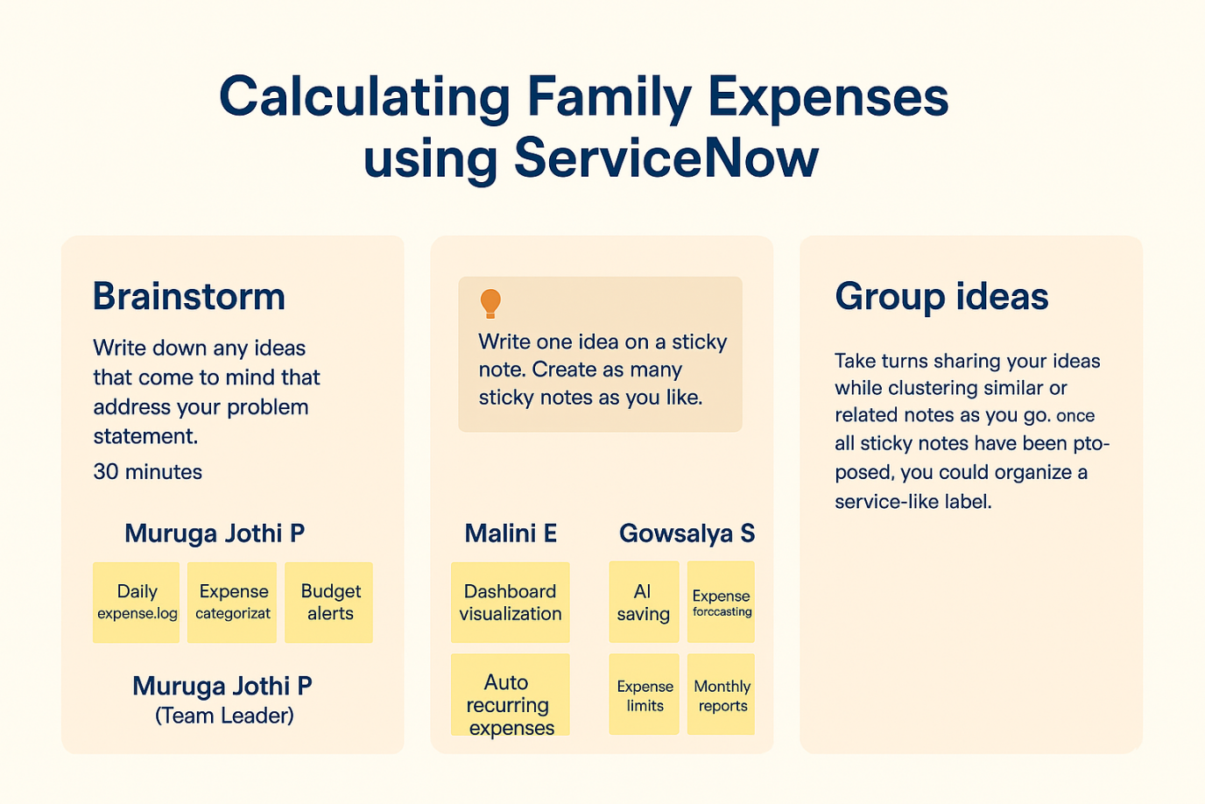

Step-3: I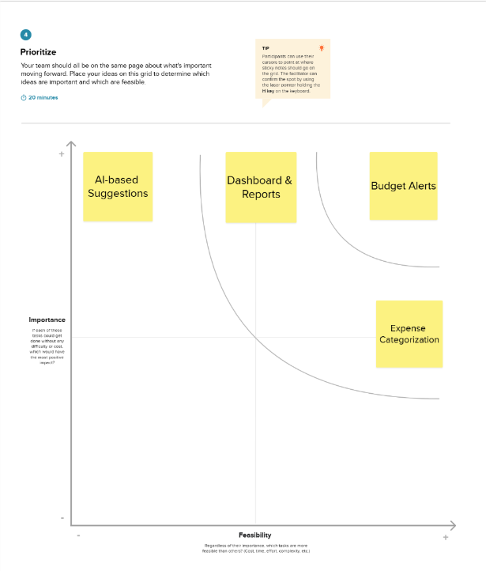Prioritization Idea

